Useless Fun Fact Web App

# Objective

The objective of this project is to develop a light-hearted and engaging web application that provides users with random fun facts and humorous advice, as well as the ability to submit their own fun facts.

# Project Overview

This web application is built using the Flask framework for the backend, with HTML and CSS for the frontend. It displays a "Fact of the Day", a random fun fact, and a piece of advice. Users can also submit new fun facts, which are added to the existing collection dynamically.

# Technology Stack

• Python (Flask Framework)  
• HTML5 & CSS3  
• JavaScript (for dynamic form submission)  
• Jinja2 Templating (Flask built-in)

# Backend Python Code (app.py)

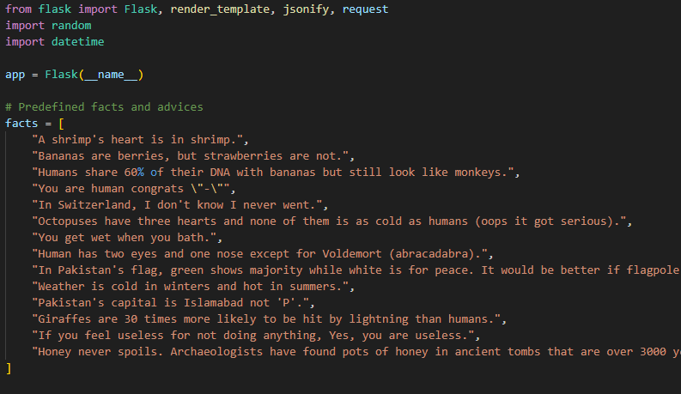  
# app.py highlights:  
1. Randomly select and return a fun fact and advice.  
2. Provide 'fact of the day' based on calendar day.  
3. Accept new facts via POST request and add to the list.

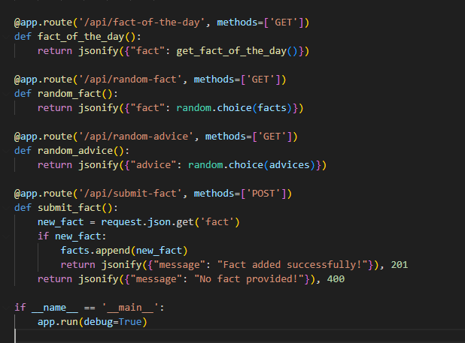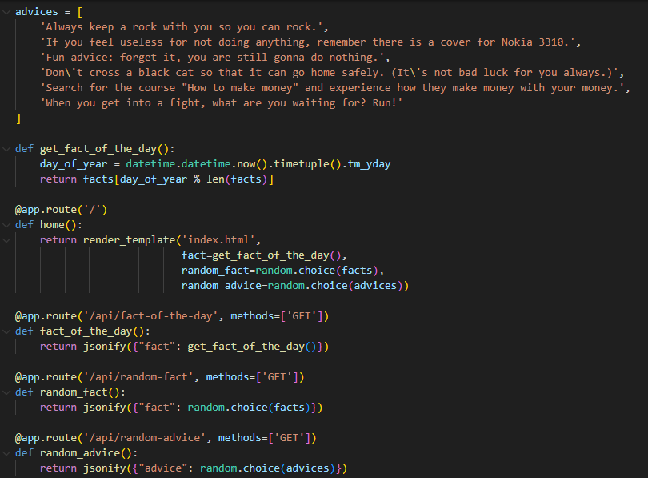

# HTML (index.html)

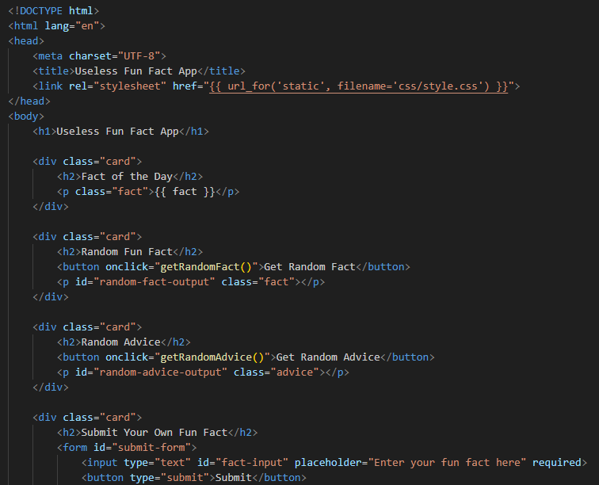The index.html uses Jinja2 templating to dynamically show the fact of the day, random fact, and advice. A submission form allows the user to input new facts using JavaScript fetch API.

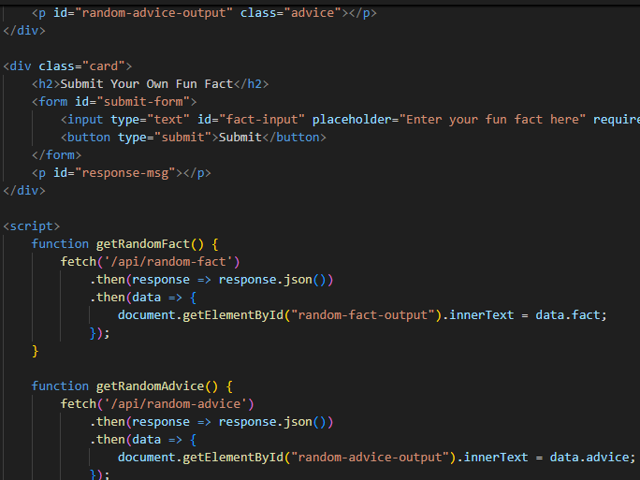

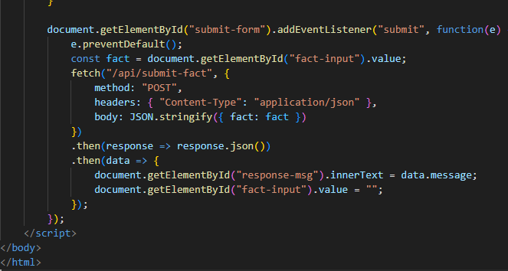

# CSS (style.css)

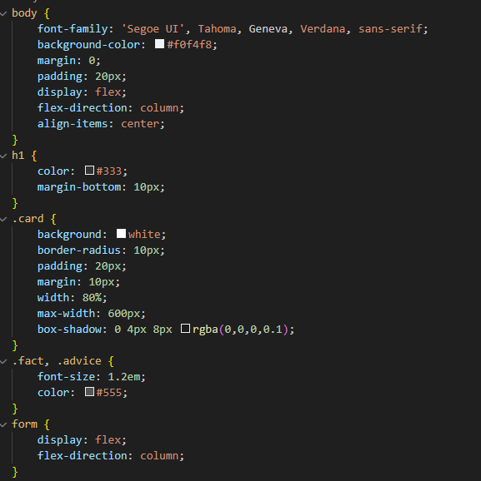The CSS file provides styling for the overall layout, cards, inputs, and buttons. It ensures that the frontend is visually appealing and responsive.

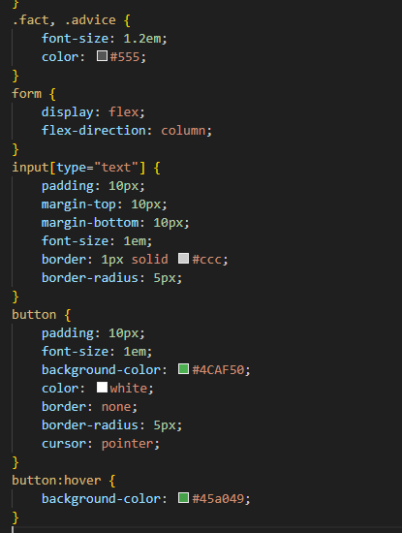

# Features and Functionality

• Show daily and random fun facts and advice  
• Accept and store user-submitted fun facts  
• Use AJAX to send form data without reloading the page  
• Clean and responsive user interface

# Sample Output

Upon visiting the homepage, users are greeted with three cards: one displaying a fact of the day, another showing a random fact, and a third for humorous advice. Submissions appear successful via a confirmation message.

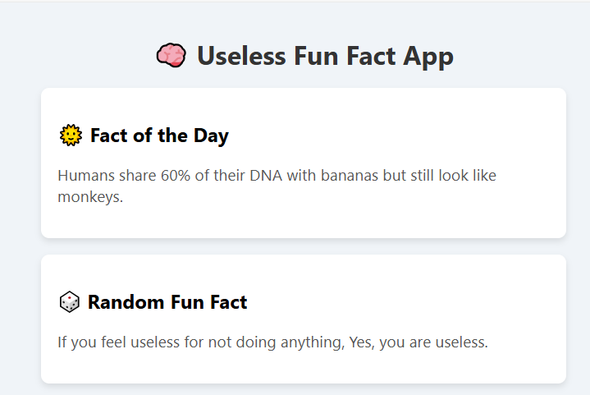

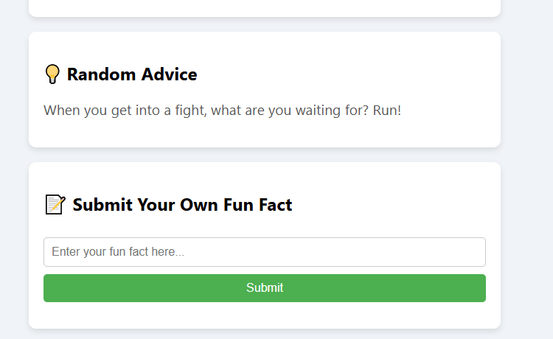

# Conclusion

This Useless Fun Fact App demonstrates how a simple web application can entertain users with random content. It also showcases the integration of backend and frontend technologies to build dynamic, interactive web apps.